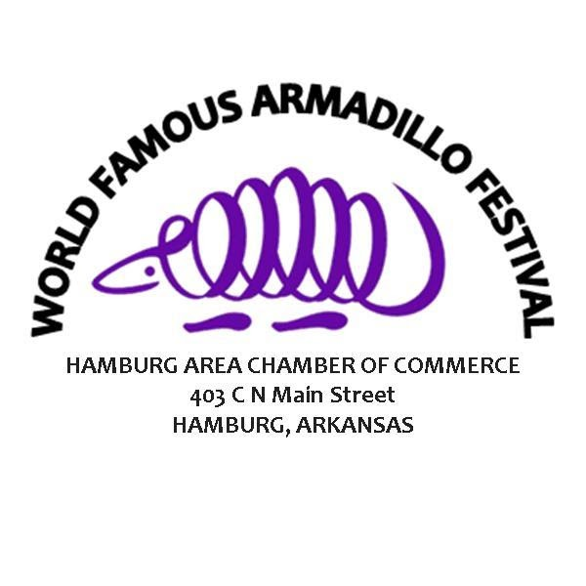
WORLD FAMOUS ARMADILLO FESTIVAL
Saturday, May 7th, 2021

POLITICAL CANDIDATES
DEADLINE: APRIL 1st, 2022

Political Candidate’s Name: ______________________________________________________

Office Running For: ____________________________________________________________

Phone: _______________________________________________________________________

Address: _____________________________________________________________________

City ______________________________State_________________ Zip___________________

Contact Name: ________________________________________________________________

Phone: _____________________________________ Cell: _____________________________

Email: _______________________________________________________________________

Electricity: ____________Yes _____________No

Please indicate what you will sell or what the booth will be used for:
_________________________________________________________________________________________________________________________________________________________________________________________________________________________________________________________________________________________________________________________________________________________________________________________________
_______________________________________________________________________________________________________________________________________________________________________________________________________________________________________
COST: $200.00 SIZE: 10’ X 10’

GUIDELINES
- Check-in and set-up will BEGIN Saturday at 6:00 a.m. Streets will not be closed until then so please do not try to set up early. Each vendor must check-in with the vendor committee to find their assigned booth space. Please turn left at Handi Corner to Hwy 8, turn left on S Mulberry St, you will then drive straight down till you are greeted kindly by our vendor committee. (NO VENDOR MAP WILL BE GIVEN PRIOR TO THE FESTIVAL.) On Saturday, vendors must have their booths ready for business by 8:00 a.m. Go directly to your assigned space. After initial unloading, vendors will park their vehicles in another area. (DO NOT ARRIVE BEFORE 5:30 A.M!)

- Vendors are responsible for the appearance of their booth and must clean up after the festival. You may not work out of your bus, van, car, motor home, etc. Tables, chairs, and tents are not provided.

- No exhibit may be set up as to obstruct vision of or access to stores, another exhibit, or as to impede the free flow of traffic.

- No pets allowed.

- No beverages or (competing) food items are allowed for sale or to be given away.

- Political Booth spaces will be assigned by the Armadillo Festival Committee.

- NO political issues are allowed. *One Candidate or Organization per Booth.

- No refunds will be made for inclement weather or other acts of God over which the sponsors have no control and the risk of loss as such, shall be borne by the vendor. The festival will not be responsible for damaged or stolen property, accidents, or fire.

- Reservations will be confirmed with a receipt of payment.

SUBMISSION: send this application and a check made out to the Hamburg Area Chamber of Commerce

Mail to:
World Famous Armadillo Festival
403 C N Main Street
Hamburg, AR 71646

• Questions?
Contact Hannah Morton, Executive Director at W: 870-853-8345 C: 870-723-8516 or email: chamberofcommercehamburg@gmail.com

