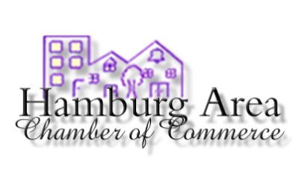
Hamburg Pride Banner Order Form
Show your Hamburg Pride by sponsoring a banner to be displayed on light poles on Main Street and around the Square. Anyone is welcome to purchase a banner. Banners may be sponsored in honor of students, classes, businesses, family, or in memory of someone. Forms & payment can be mailed to the Hamburg Area Chamber office OR dropped off at the following locations: Jade office, Yours & Vine, M&M Tire. Make checks payable to the Hamburg Chamber of Commerce.
DEADLINE TO RETURN FORMS IS MARCH 1, 2021.

Purchaser Name: _______________________________________________________
Phone Number: _________________________________________________________
Sponsored Name (What will appear on the banner - limit 40 characters)
Banners are easier to read when there isn’t a lot of wording, so keep this in mind when choosing your personalization. What you write below is exactly what will appear on the banner. Your personalization will replace “City of Hamburg.”

________________________________________________________________________________________________

Banners will be offered for the time spans listed below. Sponsor will own the 2’X4’ banner after the selected time span is up and it is taken down. Please circle your desired option.
- 1 year: $175
- 2 years: $225
- 3 years: $250

403 C North Main Street, Hamburg, AR 71646 𑁦 (870)853-8345 𑁦 chamberofcommercehamburg@gmail.com

